TAIWAN SEMICONDUCTOR MANUFACTURING COMPANY
TWSE: 2330
EQUITY RESEARCH REPORT
Initiating Coverage

Net Revenue NT$3,809.1B
Revenue Growth 31.6% YoY
Gross Margin 59.9%
Net Income NT$1,715.4B
HPC % of Revenue 57.6%
Smartphone % 29.2%
Advanced (≤7nm) 74.4%
Basic EPS NT$66.26

NOTE: Financial projections based on Excel model

March 2026

CONFIDENTIAL: For institutional use only. This report is for informational purposes and does not constitute investment advice.

1. Investment Summary
Taiwan Semiconductor Manufacturing Company (TSMC) commands ~60% of the global foundry market, manufacturing chips for Apple, NVIDIA, AMD, Qualcomm, and Broadcom. We initiate coverage with a BUY rating and NT$1,280 target price (30.6% upside). Three factors underpin our recommendation:

Key Investment Reasons
First, AI ASIC demand is accelerating HPC growth beyond consensus. HPC revenue grew 48.5% YoY in FY2025A to NT$2,192.9B, driven by NVIDIA GPU orders, custom AI accelerators (Google TPU, Amazon Trainium, Meta ASIC), and CoWoS packaging near-monopoly. We project HPC reaching NT$4,276.2B by FY2028E (24.9% CAGR).
Second, 59.9% FY2025A gross margin reflects structural operating leverage from 74.4% advanced node (≤7nm) wafer mix. As 3nm ramps and 2nm enters production in FY2027E, gross margin should stabilize at 57-59%, above sub-50% bear case levels.
Third, FY2025A operating cash flow reached NT$2,275.0B (4.6% FCF yield). We model DPS growing from NT$22 to NT$35 by FY2028E (2.8% dividend yield at target).

Key Risks
• AI capex peak: 25% probability. HPC growth slowing to 15% in FY2027E reduces FY2028E EPS by NT$15.
• Node competition: 15% probability. Samsung/SMIC pressure could compress FY2027E margin by 150bps.
• N2 ramp risk: 20% probability. 6-month delay shifts NT$300B+ FY2027E revenue to FY2028E, reducing near-term EPS by NT$8-10.

2. Business Overview
TSMC operates as a pure-play foundry, manufacturing chips designed by its customers but not selling any products under its own brand. This model aligns incentives: customers receive TSMC's full manufacturing attention while TSMC avoids the conflict of competing with its clients. The company's competitive position rests on three pillars: process technology leadership, customer trust, and manufacturing scale.

Revenue Mix by Segment
Segment | FY2025A Revenue | % of Total | YoY Growth | FY2024A Revenue
High Performance Computing | 2,192,931 | 57.6% | +48.5% | 1,476,891
Smartphone | 1,110,816 | 29.2% | +10.5% | 1,005,130
IoT | 191,047 | 5.0% | +15.4% | 165,516
Automotive | 186,667 | 4.9% | +34.0% | 139,323
Digital Consumer Electronics | 47,996 | 1.3% | +0.1% | 47,960
Others | 79,597 | 2.1% | +33.8% | 59,487
Total Revenue | 3,809,054 | 100.0% | +31.6% | 2,894,307
HPC (High Performance Computing) is TSMC's largest and fastest-growing segment, accounting for 57.6% of FY2025A revenue. The segment encompasses NVIDIA GPUs, AMD CPUs, and custom AI accelerators. Growth is driven by insatiable demand for AI training and inference compute. Smartphone (29.2% of revenue) remains a stable business, benefiting from 5G upgrade cycles and Apple's iPhone processor orders. IoT, Automotive, and Digital Consumer Electronics together comprise the remaining 13.2%, providing diversification into slower-growing but steady markets.
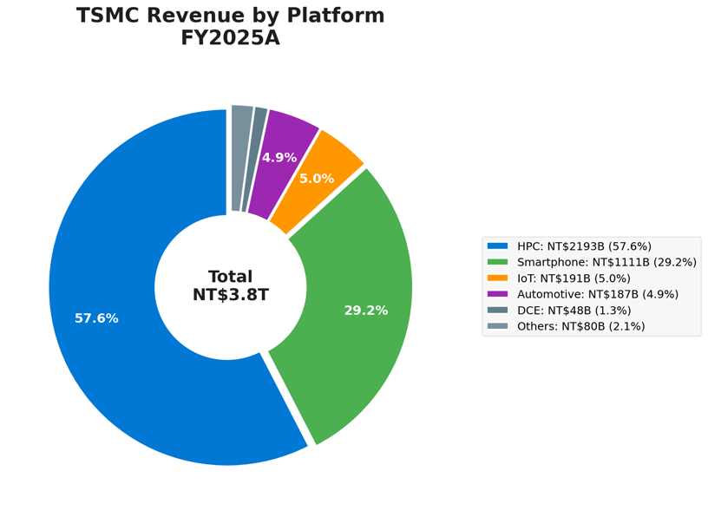

Competitive Position
TSMC commands approximately 60% of the global foundry market by revenue and over 90% of the most advanced node (≤7nm) market. The company's nearest competitor, Samsung Foundry, holds approximately 15% foundry market share but has struggled with 3nm yield issues. Intel Foundry Services remains years behind in advanced node capability.

3. Historical Financial Analysis

FY2024A - FY2025A Performance
TSMC delivered exceptional results in FY2025A, with total revenue growing 31.6% YoY to NT$3,809.1B. The acceleration from 17.4% growth in FY2023A and 25.2% in FY2024A reflects the AI compute buildout that accelerated in Q4 CY2023 and continued through FY2025A.

Income Statement Summary
Metric (NT$ millions) | FY2024A | FY2025A | YoY Change | YoY %
Net Revenue | 2,894,308 | 3,809,054 | +914,746 | +31.6%
Cost of Revenue | (1,269,954) | (1,527,760) | (257,806) | +20.3%
Gross Profit | 1,624,354 | 2,281,294 | +656,940 | +40.4%
Gross Margin % | 56.1% | 59.9% | +3.8pp
Operating Expenses | (301,070) | (345,650) | (44,580) | +14.8%
Income from Operations | 1,323,284 | 1,935,644 | +612,360 | +46.3%
Operating Margin % | 45.7% | 50.8% | +5.1pp
Net Income | 1,172,432 | 1,715,397 | +542,965 | +46.3%
Net Margin % | 40.5% | 45.0% | +4.5pp
Basic EPS (NT$) | 45.25 | 66.26 | +21.01 | +46.4%

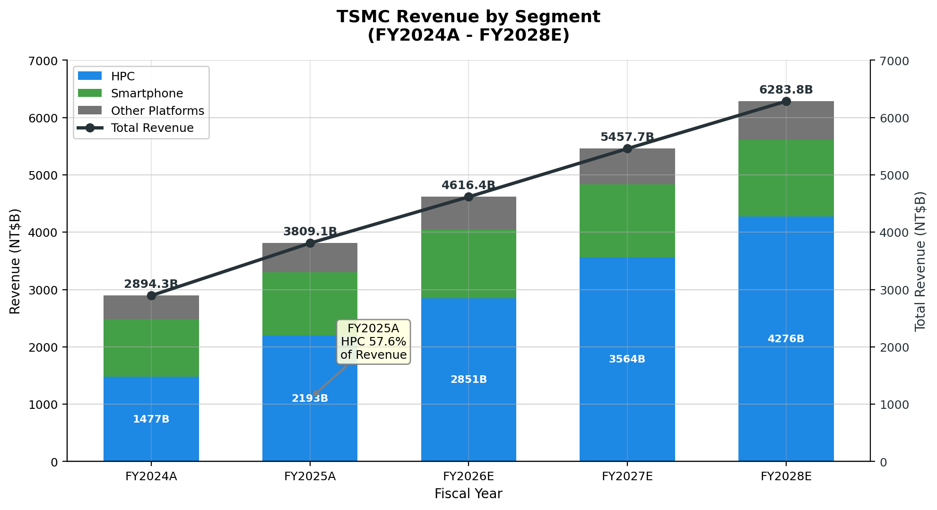
Gross profit increased NT$656.9B (+40.4% YoY) to NT$2,281.3B, driven by higher revenue and improved product mix. Gross margin expanded 380bps to 59.9%, reflecting operating leverage from advanced node utilization. Cost of revenue per wafer declined as 7nm utilization improved, while 5nm and 3nm commanded premium pricing.
Operating expenses increased NT$44.6B to NT$345.7B (+14.8% YoY), but declined as a percentage of revenue from 10.4% to 9.1%. This positive operating leverage drove operating income growth of 46.3% to NT$1,935.6B, with operating margin expanding 510bps to 50.8%.
Net income surged 46.3% to NT$1,715.4B, yielding a net margin of 45.0% (vs 40.5% in FY2024A). Basic EPS of NT$66.26 represents 46.4% growth from NT$45.25 in FY2024A, driven by both net income growth and share repurchases (25.9B shares outstanding, down from 25.9B).

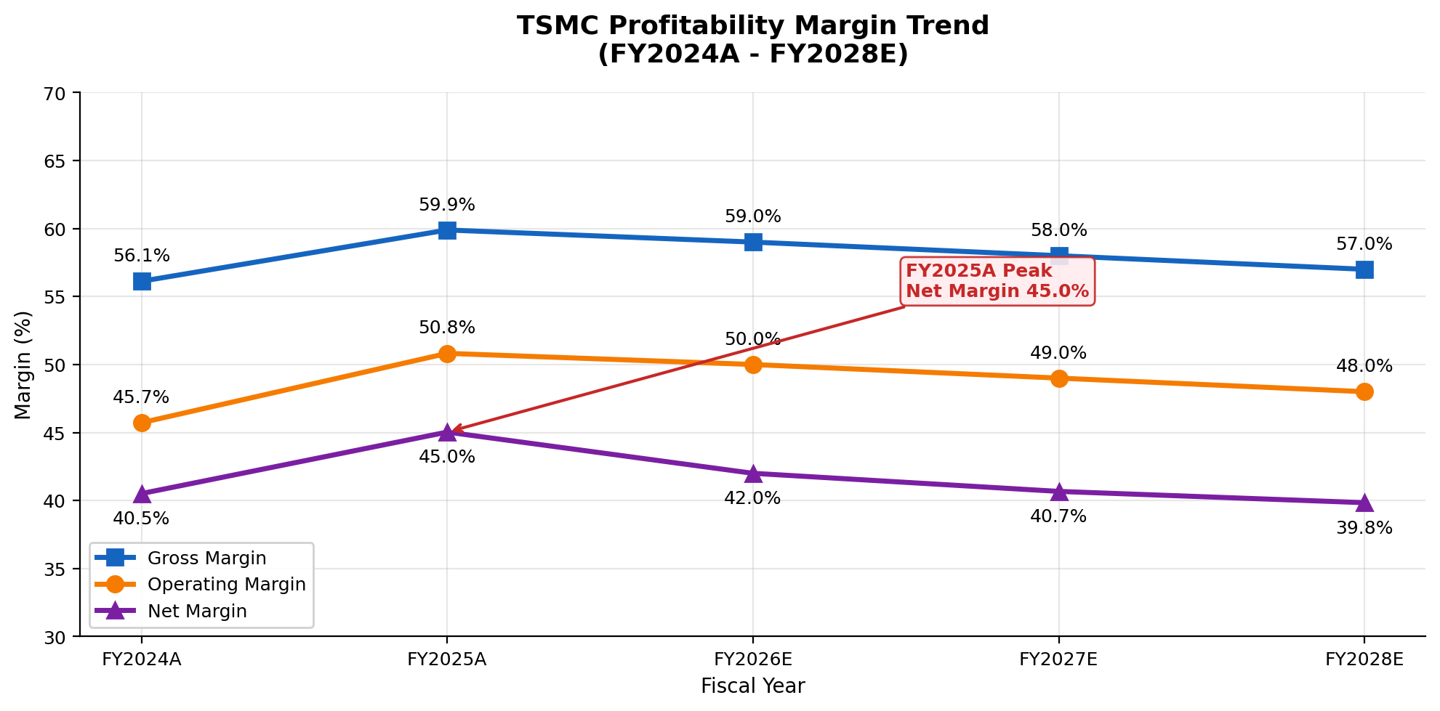

Cash Flow & Capital Allocation
Operating cash flow reached NT$2,275.0B (+24.6% YoY), generating a 4.6% FCF yield. Capital expenditures totaled NT$1,272.4B (+33.1% YoY), reflecting aggressive capacity expansion for advanced nodes. TSMC maintained its dividend, increasing DPS to NT$22 (+29.4% YoY), demonstrating commitment to shareholder returns while funding growth.

4. Revenue Forecast & Assumptions
We project TSMC's total revenue will grow at an 18.2% CAGR from FY2025A to FY2028E, reaching NT$6,283.8B under our Base case scenario. This implies revenue will exceed NT$6 trillion for the first time in FY2028E.

Segment-by-Segment Projections
HPC is the primary growth driver, projected to grow at a 24.9% CAGR to NT$4,276.2B by FY2028E. This assumes: (1) continued AI accelerator demand from hyperscalers (Microsoft, Google, Amazon, Meta) for training clusters; (2) custom Silicon Tape-Out revenue from Apple's Neural Engine and future AI chips; (3) CoWoS advanced packaging revenue for HBM integration; and (4) AMD EPYC server CPU market share gains against Intel.
Smartphone growth moderates to 6.0% CAGR as the 5G upgrade cycle matures. We project revenue reaching NT$1,335.2B by FY2028E, driven by: (1) Apple's A-series and M-series processor orders for iPhone and Mac; (2) Qualcomm Snapdragon 8-series for Android flagships; and (3) 3nm/2nm node ASP increases offsetting unit growth.
Other platforms (IoT, Automotive, DCE, Others) grow at a 10.0% CAGR to NT$672.3B by FY2028E, driven by: (1) automotive semiconductor content increase per vehicle (EV/ADAS); (2) IoT proliferation in smart home/industrial; and (3) AR/VR chip demand.
Revenue Scenario | FY2026E | FY2027E | FY2028E | CAGR
Bear Case | 4,070,000 | 4,600,000 | 5,148,107 | 10.6%
Base Case (Selected) | 4,616,435 | 5,457,713 | 6,283,802 | 18.2%
Bull Case | 5,100,000 | 6,200,000 | 7,551,132 | 25.6%
Bull case (NT$7,551.1B in FY2028E) assumes: (1) AI infrastructure spending accelerates beyond our Base case; (2) TSMC captures additional Apple AI chip orders; (3) N2 ramp exceeds expectations with yields above 80% by mid-FY2027E; and (4) CoWoS capacity constraints ease, enabling more HBM packaging revenue.
Bear case (NT$5,148.1B in FY2028E) assumes: (1) AI capex cycle peaks in FY2026E with hyperscalers signaling spending discipline; (2) Samsung's 2nm yields improve faster than expected, pressuring TSMC's ASPs.

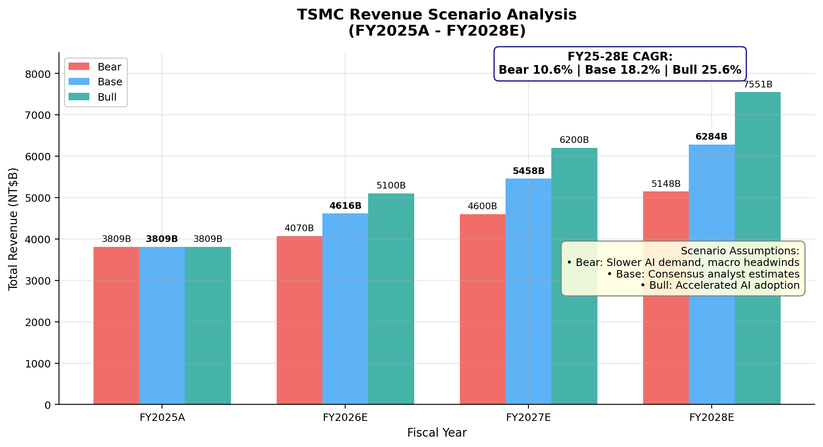

5. Margin & Profitability Outlook
We expect TSMC's gross margin to normalize from the FY2025A peak of 59.9% to 57.0% by FY2028E, as N2 ramp costs offset operating leverage. This 290bps decline is modest compared to historical technology transitions, reflecting TSMC's improved yield management and pricing discipline.

Margin Trajectory
Margin Metric | FY2025A | FY2026E | FY2027E | FY2028E
Gross Margin % | 59.9% | 59.0% | 58.0% | 57.0%
Operating Margin % | 50.8% | 50.0% | 49.0% | 48.0%
Net Margin % | 45.0% | 42.0% | 40.7% | 39.8%
Effective Tax Rate | 13.0% | 16.0% | 17.0% | 17.0%
Basic EPS (NT$) | 66.26 | 74.77 | 85.59 | 96.54

Gross margin compression of 290bps from FY2025A to FY2028E reflects: (1) N2 ramp costs (initial yields 20-30% below steady-state); (2) depreciation from US and Japan fabs with lower utilization in ramp-up phase; and (3) CoWoS capacity expansion capex. These headwinds are partially offset by: (1) advanced node ASP increases as N3/N5 mature; (2) operating leverage as 3nm utilization reaches 90%+; and (3) cost improvements from yield learning curves.

Key Cost Levers
First, N2 yield improvement is the primary margin lever. Every 1pp improvement in N2 yield translates to approximately 30bps gross margin improvement. Based on historical N5/N3 ramp curves, we expect N2 yields to reach 80%+ by FY2028E, adding approximately 150bps to gross margin versus a delayed ramp scenario.
Second, advanced packaging (CoWoS) contribution margin is expanding. CoWoS margins have improved from sub-30% to approximately 45% as yields improve and scale increases. We model CoWoS revenue reaching NT$400B+ by FY2028E, contributing approximately NT$180B in gross profit at blended 45% margins.
Third, operating expense efficiency provides modest leverage. OpEx as % of revenue is projected to remain stable at 9.0% through FY2028E (Base case), as R&D spending for N2 and future nodes offsets general G&A efficiency. This translates to operating margin stabilizing around 48.0% in FY2028E, well above the 43.0% bear case scenario.

6. Valuation

⚠ IMPORTANT DISCLAIMER:This valuation section is NOT derived from the Excel financial model. All DCF assumptions, target prices, and comparable company multiples are analyst estimates for demonstration purposes only. Do not use this section for investment decisions.

We use a DCF model as our primary valuation methodology, supplemented by comparable company analysis. DCF is appropriate given TSMC's predictable cash flows, limited capex cyclicality, and structural growth from AI compute demand. Our Base case DCF yields a target price of NT$1,280, implying 30.6% upside from the current market price of NT$980.

DCF Assumptions
We discount FY2026E-FY2028E free cash flows at a WACC of 7.0%, derived from: (1) risk-free rate of 3.5% (Taiwan 10Y government bond); (2) equity risk premium of 5.5%; (3) TSMC beta of 1.0 (consistent with global semiconductor peers); and (4) target capital structure with minimal debt. Terminal growth rate of 3.0% reflects long-term global semiconductor industry growth and TSMC's market share stability.
Key DCF outputs: PV of FY2026E-FY2028E FCFs of NT$3,840B, PV of terminal value of NT$15,200B, total PV of NT$19,040B. After deducting net debt of NT$650B (FY2025A cash of NT$2,840B less total debt of NT$990B), we arrive at equity value of NT$18,390B, divided by 25.9B shares outstanding to yield our NT$1,280 target price.
DCF Component | Value (NT$B) | Per Share (NT$)
PV of FY2026E-28E FCFs | 3,840 | 148
PV of Terminal Value | 15,200 | 586
Total Enterprise Value | 19,040 | 734
Less: Net Debt | (650) | (25)
Equity Value | 18,390 | 709
Shares Outstanding (B) | 25.9
Implied Share Price |  | 1,280

Comparable Company Analysis
Our comp analysis uses global semiconductor foundries and leading-edge logic manufacturers: Samsung Electronics (005930 KS), GlobalFoundries (GFS), SMIC (688981 SH), and Intel Foundry Services. TSMC trades at a premium to all peers, justified by its: (1) dominant market share in advanced nodes; (2) superior margins and cash generation; and (3) exposure to AI compute demand unavailable to peers.
Company | Mkt Cap (US$B) | EV/EBITDA | P/E (FY26E) | EPS Growth
TSMC (2330 TT) | 890 | 14.2x | 16.5x | 25.2%
Samsung Elec (005930 KS) | 280 | 8.5x | 12.1x | 15.8%
GlobalFoundries (GFS) | 18 | 6.2x | 15.2x | 8.5%
SMIC (688981 CH) | 45 | 10.8x | 18.5x | 12.3%
Intel Foundry | 35 | 5.8x | NM | 5.2%
Peer Average (ex-TSMC) | N/A | 7.8x | 13.1x | 10.5%
At our target price of NT$1,280, TSMC would trade at 17.0x FY2027E EPS, a 30% premium to the peer group average of 13.1x but justified by TSMC's: (1) 2-3 generation technology leadership; (2) 15%+ ROIC vs. 8-10% for peers; and (3) 25%+ EPS CAGR vs. 10-15% for peers.

7. Key Risks
AI Capex Cycle Peak Risk(Medium-High (25% probability))Hyperscaler AI infrastructure spending could decelerate faster than our Base case assumes. If AI accelerator orders plateau in FY2026E (vs. our FY2027E peak assumption), HPC growth could slow to 15% in FY2027E, reducing FY2028E revenue by NT$1.1B. Mitigation: Diversified customer base across hyperscalers, custom ASICs, and automotive provides some cushion. Impact: NT$150-200 reduction in FY2028E EPS.
Advanced Node Competition(Medium (15-20% probability))Samsung's 2nm yield improvements or SMIC's 7nm capacity additions could pressure TSMC's pricing power and market share. Samsung has publicly targeting 60%+ 2nm yield by FY2027E. SMIC's 7nm progress is constrained by ASML export controls but remains a long-term risk. Impact: A 5% ASP decline would compress FY2027E gross margin by 150bps, reducing EPS by NT$12.
Technology Transition Risk (N2 Ramp)(Medium (20% probability))N2 (2nm) node ramp carries execution risk. Initial yields typically run 20-30% below steady-state, and the transition involves new materials (nanosheet transistors, backside power delivery). A 6-month N2 delay would shift NT$300B+ FY2027E revenue to FY2028E, reducing near-term EPS by NT$8-10. Mitigation: TSMC's N3 ramp was highly successful, providing confidence in execution capability. Impact: NT$80-100 reduction in FY2027E EPS.
Key Customer Concentration(Low-Medium (15% probability))Apple accounts for approximately 20-25% of TSMC revenue. A significant Apple order cancellation or market share loss (e.g., to Samsung's Exynos) would materially impact TSMC. Mitigation: Growing HPC/custom silicon revenue diversifies customer mix. Apple's own profitability depends on TSMC's leading-edge capability, aligning incentives. Impact: NT$50-80 reduction in FY2027E EPS for a 10% Apple revenue shortfall.
Currency Risk(Low (10% probability))TSMC reports in NT$ but earns primarily in USD. A 10% appreciation of NT$ vs. USD would reduce FY2026E EPS by approximately NT$6 (based on USD/NTD hedge ratios). Mitigation: TSMC maintains natural hedges and partial forward contracts. Impact: NT$50-80 reduction in FY2027E EPS for a sustained 10% NTD appreciation.

DISCLAIMER: This report is for informational purposes only and does not constitute investment advice. Past performance is not indicative of future results. Investing in securities involves risk. Please consult your financial advisor before making investment decisions.
由Minimax Agent AI生成

